1. **Set the base image to Ubuntu**
   * **Add File Author / Maintainer**

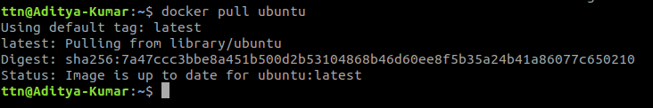

* + **Install Nginx**
  + **Install necessary tools: vim wget curl net-tools**
  + **Remove the default Nginx configuration file**
  + **Copy a configuration file from the current directory**
  + **Expose ports (80)**
  + **Set the default command to execute when creating a new container**

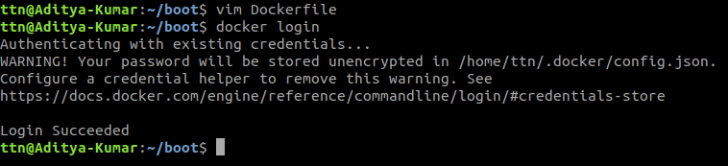

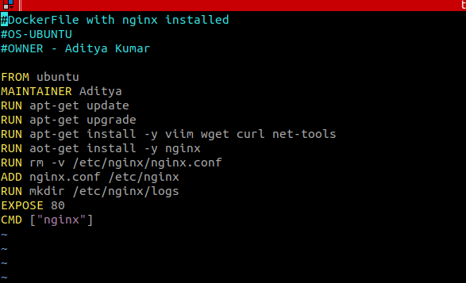

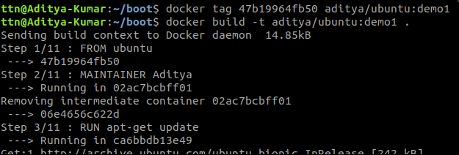

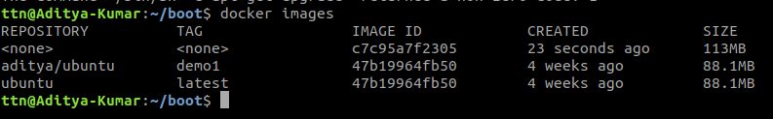

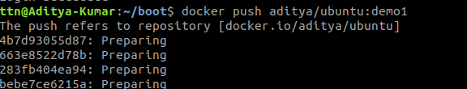

1. **What is the difference between 'RUN', 'CMD', & 'ENTRYPOINT' in dockerfile?**

RUN executes commands in a new layer and creates a new image. E.g.,it is often used for installing software packages.

CMD sets default command and/or parameters, which can be overwritten from command line when docker container runs.

ENTRYPOINT configures a container that will run as an executable.

1. **How to connect docker client to docker daemon running on other host?**

